What Is an MSME Loan? Meaning, Types, Eligibility & How to Apply in 2026
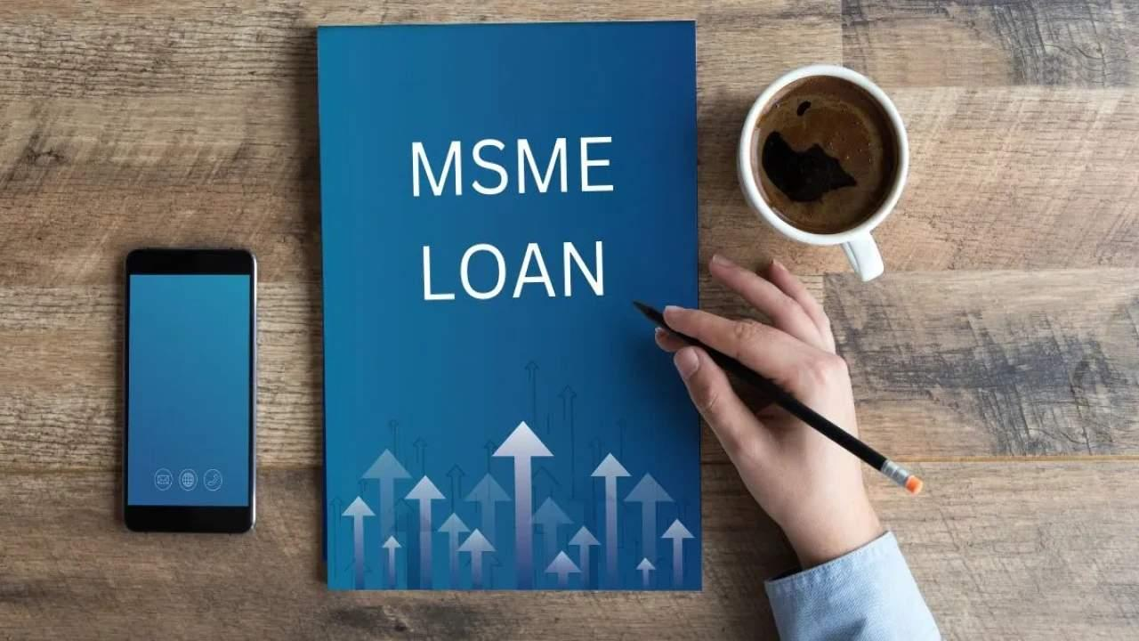
Image Source
Vikram runs a packaging unit in Pune. Orders worth Rs 80 lakh are lined up and his clients pay on 60-day terms, so he needs Rs 25 lakh for raw material this month. He owns no spare property to pledge. That gap between a full order book and an empty current account is what an MSME loan is built for, and some version of it turns up in most of the 7.83 crore businesses now registered on the Udyam portal.
To Avail Unsecured Business Loans Apply Now

What Is an MSME Loan?
An MSME loan is credit for a business registered as a micro, small or medium enterprise on the Udyam portal. Banks lend it, so do NBFCs and microfinance institutions, secured or unsecured depending on what you can pledge. What separates it from an ordinary business loan is Priority Sector Lending. RBI obliges every bank to push a set share of its credit into this segment, which is why the rate and terms usually beat what the same firm would get on a plain commercial loan. Registration on Udyam costs nothing and takes about half an hour if your Aadhaar is linked to a live mobile. Skip it and none of the schemes below apply.

MSME Classification From 1 April 2025
Category | Investment in plant, machinery or equipment | Annual turnover
Micro | Up to Rs 2.5 crore | Up to Rs 10 crore
Small | Up to Rs 25 crore | Up to Rs 100 crore
Medium | Up to Rs 125 crore | Up to Rs 500 crore

Both tests apply at once. Cross either line and you move up a category, which changes the schemes you qualify for. Figures come from the Ministry of MSME, Notification S.O. 1364(E) of 21 March 2025. On the same ministry's numbers the sector supplies about 45.8% of India's exports.

How Is an MSME Loan Used?
Most MSME loans carry no end-use restriction, so the money goes wherever the month demands.
- Working capital takes the largest share by far. Raw material, festive-season stock, wages through a quarter when nobody is paying on time.
- Expansion comes next. A second unit, a bigger godown, or a product line the existing plant cannot make.
- Some borrowers put it into machinery, or into software that stops a growing firm losing track of its own stock.
- Exporters draw on it for pre-shipment and post-shipment finance while a consignment sits on a ship.
- Plenty refinance costlier debt, swapping an 18% overdraft for a 12% term loan and keeping the difference.

Types of MSME Loans in India
- A term loan hands over a lump sum and takes it back in fixed EMIs across 12 to 84 months. Machinery and new units get funded this way.
- Working capital facilities run the other way round. You draw against a sanctioned limit as you need it, paying interest only on what you have used.
- Equipment finance treats the machine you are buying as the security, which pulls the rate below an unsecured loan of the same size.
- Invoice discounting advances 70% to 90% of an unpaid invoice, so a customer's 60-day cycle stops dictating your own.
- Collateral-free loans are underwritten on GST returns and bank statements rather than assets. NBFCs usually stop at Rs 50 lakh.

Government Schemes Worth Knowing
CGTMSE matters most, because its guarantee lets a lender drop the collateral requirement on loans of up to Rs 10 crore. That ceiling doubled from Rs 5 crore on 1 April 2025. MUDRA works at the other end, covering up to Rs 20 lakh across four bands, and suits a firm too young to show three years of financials. PSB59 pulls your GST and ITR data directly, returning an in-principle decision on up to Rs 5 crore in under an hour. Stand-Up India funds women and SC/ST founders between Rs 10 lakh and Rs 1 crore. One warning. The general CLCSS subsidy closed in March 2020, so ignore any page still advertising it.

Eligibility and Documents
Lenders want an applicant aged between 21 and 65 holding an active Udyam certificate. Most ask for one to three years of trading history, although MUDRA accepts less, and a personal CIBIL score of 700 or better helps anywhere, with existing EMIs under half of monthly income.
Paperwork is standard enough. Every owner needs a PAN and an Aadhaar. Add the Udyam certificate, then 12 months of GST returns and bank statements, then two years of ITRs. Read the Key Fact Statement before you sign. It sets out the annual percentage rate and every charge attached, and it is the only page showing what the money really costs.

Frequently Asked Questions

What Documents Are Required for an MSME Loan?
Udyam certificate, PAN and Aadhaar for each owner, proof of registration. On top of that, 12 months of bank statements and GST returns, plus two years of ITRs. Secured loans add the property or machinery papers.

What Is the Repayment Tenure for an MSME Loan?
Working capital facilities run 12 months and renew each year. Term loans go longer, stretching to 84 months at banks and capping around 60 months for unsecured NBFC lending. MUDRA is typically repaid over three to five years.

Are There Subsidies Available on MSME Loans?
There are some, though none come from the lender. PMEGP pays a margin money subsidy worth 15% to 35% of project cost for a new unit, and the Special CLCSS gives SC/ST-owned enterprises 25% back on machinery. CGTMSE gets listed alongside these, but it is a guarantee, not a subsidy. No money reaches you.

Is There a Minimum Credit Score Required for an MSME Loan?
No statutory floor exists, but lenders watch two numbers. A proprietor's personal CIBIL score should ideally be 700 or above. Firms carrying credit exposure between Rs 10 lakh and Rs 50 crore also get a CIBIL MSME Rank, where 1 to 4 is comfortable and 8 to 10 is usually a decline.

